Re3 visits Umbrella Foundation
01/08/2008

Trevor and Deborah Boyd, directors of the Re3 group made a sixteen hour flight from Dublin to Kathmandu, Nepal to visit the Umbrella Foundation. Debbie Boyd, CEO of the Re3 group said;

“It had been a dream of ours for many years to take this trip to visit the orphanages and meet the children. We were especially looking forward to meeting one of our sponsor children, who we receive letters and photographs from regularly. It was wonderful to see the children and experience first hand the benefits of what the Umbrella Foundation do as a charity. It was the trip of a lifetime.”
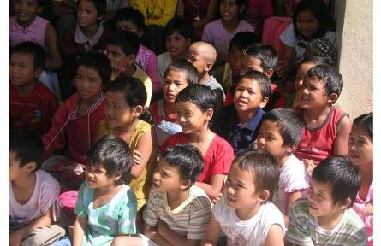

Left: Some of the Nepalese children rescued by Umbrella Foundation. Right: One of the children personally sponsored by Trevor and Debbie Boyd directors of the Re3 Group with her new bike.



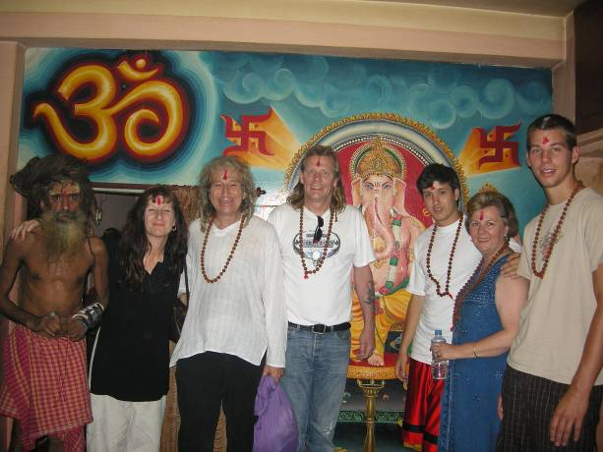

Above: Nepalese Holy Man, Viva Bell (Umbrella Founder), Jacky Buk (Umbrella Country Director), Trevor Boyd (Re3 Group), Naryan Bell (Umbrella), Debbie Boyd (CEO Re3 Group), David Bell (Umbrella Volunteer).

